**NAME : Vedvyass.M**

**REGISTER NUMBER : 192324267**

**SUBJECT :OPERATING SYSTEM**

**SUBJECT CODE:CSA0477**

**1.Create a new process by invoking the appropriate system call. Get the process identifier of the currently running process and its respective parent using system calls and display the same using a C program.**

**PROGRAM:**

#include<stdio.h> #include<unistd.h> int main()

{ printf("Process ID: %d\n", getpid() ); printf("Parent Process ID: %d\n", getpid() ); return 0;

}

**OUTPUT**

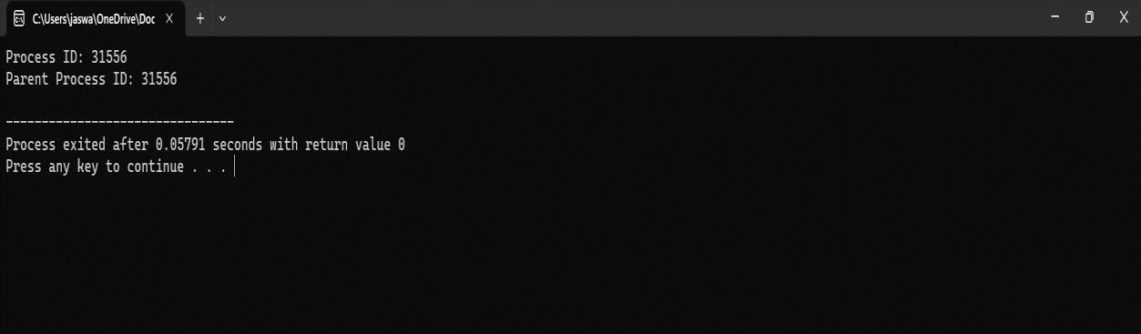

**2. Identify the system calls to copy the content of one file to another and illustrate the same using a C program**

**PROGRAM:**

#include <stdio.h>

#include <stdlib.h>

int main()

{

FILE *fptr1, *fptr2; char

filename[100], c;

printf("Enter the filename to open for reading \n"); scanf("%s", filename);

fptr1 = fopen(filename, "r"); if

(fptr1 == NULL)

{ printf("Cannot open file %s \n", filename); exit(0);

}

printf("Enter the filename to open for writing \n"); scanf("%s", filename);

fptr2 = fopen(filename, "w"); if

(fptr2 == NULL)

{ printf("Cannot open file %s \n", filename); exit(0);

} c = fgetc(fptr1); while (c != EOF)

{ fputc(c, fptr2); c

= fgetc(fptr1);

}

printf("\nContents copied to %s", filename);

fclose(fptr1); fclose(fptr2); return 0;

}

OUTPUT

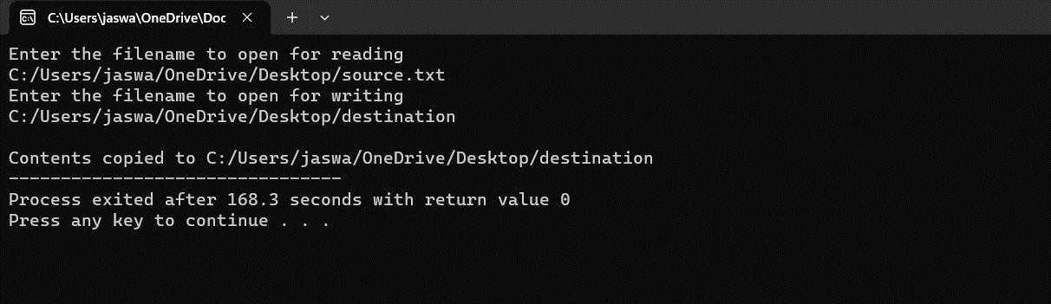

**3. Design a CPU scheduling program with C using First Come First Served**

**technique with the following considerations.**

* 1. **All processes are activated at time 0.**
  2. **Assume that no process waits on I/O devices.**

**PROGRAM:**

#include <stdio.h>

int main() {

int A[100][4]; // A[][0]: Process ID, A[][1]: Burst Time, A[][2]: Waiting Time, A[][3]: Turnaround Time

int i, j, n, total = 0, index, temp;

float avg_wt, avg_tat;

printf("Enter number of processes: ");

scanf("%d", &n);

printf("Enter Burst Time:\n");

for (i = 0; i < n; i++) {

printf("P%d: ", i + 1);

scanf("%d", &A[i][1]);

A[i][0] = i + 1; // Process ID

}

// Sorting processes based on Burst Time

for (i = 0; i < n; i++) {

index = i;

for (j = i + 1; j < n; j++) {

if (A[j][1] < A[index][1]) {

index = j;

}

}

// Swap Burst Time

temp = A[i][1];

A[i][1] = A[index][1];

A[index][1] = temp;

// Swap Process ID

temp = A[i][0];

A[i][0] = A[index][0];

A[index][0] = temp;

}

// Calculating Waiting Time

A[0][2] = 0; // First process has no waiting time

for (i = 1; i < n; i++) {

A[i][2] = 0;

for (j = 0; j < i; j++) {

A[i][2] += A[j][1];

}

total += A[i][2];

}

avg_wt = (float)total / n; // Average Waiting Time

total = 0;

// Calculating Turnaround Time

printf("\nP\tBT\tWT\tTAT\n");

for (i = 0; i < n; i++) {

A[i][3] = A[i][1] + A[i][2]; // Turnaround Time = Burst Time + Waiting Time

total += A[i][3];

printf("P%d\t%d\t%d\t%d\n", A[i][0], A[i][1], A[i][2], A[i][3]);

}

avg_tat = (float)total / n; // Average Turnaround Time

printf("Average Waiting Time = %.2f\n", avg_wt);

printf("Average Turnaround Time = %.2f\n", avg_tat);

return 0;

}

}

**OUTPUT**

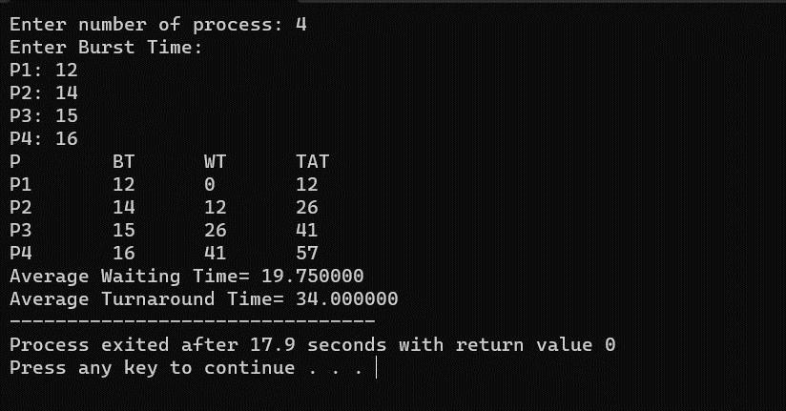

**4. Construct a scheduling program with C that selects the waiting process with the smallest execution time to execute next.**

**PROGRAM:**

#include<stdio.h>

int main()

{ int bt[20],p[20],wt[20],tat[20],i,j,n,total=0,pos,temp; float avg_wt,avg_tat;

printf("Enter number of process:"); scanf("%d",&n); printf("nEnter Burst Time:\n"); for(i=0;i<n;i++)

{ printf("p%d:",i+1); scanf("%d",&bt[i]); p[i]=i+1; } for(i=0;i<n;i++){ pos=i; for(j=i+1;j<n;j++)

{ if(bt[j]<bt[pos]) pos=j;

} temp=bt[i]; bt[i]=bt[pos]; bt[pos]=temp;

temp=p[i]; p[i]=p[pos]; p[pos]=temp;

} wt[0]=0; for(i=1;i<n;i++)

{ wt[i]=0; for(j=0;j<i;j++)

wt[i]+=bt[j];

total+=wt[i];

} avg_wt=(float)total/n; total=0;

printf("nProcesst Burst Time tWaiting TimetTurnaround Time\n"); for(i=0;i<n;i++)

{ tat[i]=bt[i]+wt[i]; total+=tat[i]; printf("np%dtt %dtt %dttt%d",p[i],bt[i],wt[i],tat[i]);

} avg_tat=(float)total/n; printf("nnAverage Waiting Time=%f",avg_wt); printf("nAverage Turnaround Time=%fn",avg_tat);

}

**OUTPUT**

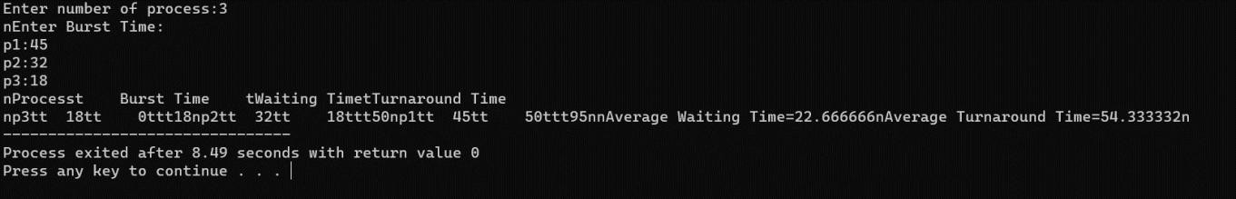

**5. Construct a scheduling program with C that selects the waiting process with the highest priority to execute next.**

**Program:-**

#include<stdio.h> struct priority_scheduling { char

process_name; int burst_time; int waiting_time; int turn_around_time; int priority; }; int main() {

int number_of_process; int total = 0;

struct priority_scheduling temp_process; int ASCII_number = 65;

int position; float average_waiting_time; float average_turnaround_time;

printf("Enter the total number of Processes: "); scanf("%d", & number_of_process);

struct priority_scheduling process[number_of_process]; printf("\nPlease Enter the Burst Time and Priority of each process:\n"); for (int i = 0; i < number_of_process; i++) {

process[i].process_name = (char) ASCII_number;

printf("\nEnter the details of the process %c \n", process[i].process_name);

printf("Enter the burst time: "); scanf("%d", & process[i].burst_time); printf("Enter the priority: "); scanf("%d", & process[i].priority); ASCII_number++; }

for (int i = 0; i < number_of_process; i++) {

position = i;

for (int j = i + 1; j < number_of_process; j++) {

if (process[j].priority > process[position].priority) position

= j; } temp_process = process[i]; process[i] =

process[position]; process[position] = temp_process; } process[0].waiting_time =

0; for (int i = 1; i < number_of_process; i++) {

process[i].waiting_time = 0; for (int j = 0; j < i; j++) {

process[i].waiting_time += process[j].burst_time; }

total += process[i].waiting_time; } average_waiting_time = (float) total / (float) number_of_process; total = 0;

printf("\n\nProcess_name \t Burst Time \t Waiting Time \t Turnaround

Time\n");

printf(" \n");

for (int i = 0; i < number_of_process; i++) {

process[i].turn_around_time = process[i].burst_time + process[i].waiting_time;

printf("\t %c \t\t %d \t\t %d \t\t %d", process[i].process_name, process[i].burst_time, process[i].waiting_time, process[i].turn_around_time);

printf("\n \n"); }

average_turnaround_time = (float) total / (float) number_of_process; printf("\n\n

Average Waiting Time : %f", average_waiting_time); printf("\n Average

Turnaround Time: %f\n", average_turnaround_time); return 0;

**OUTPUT:**

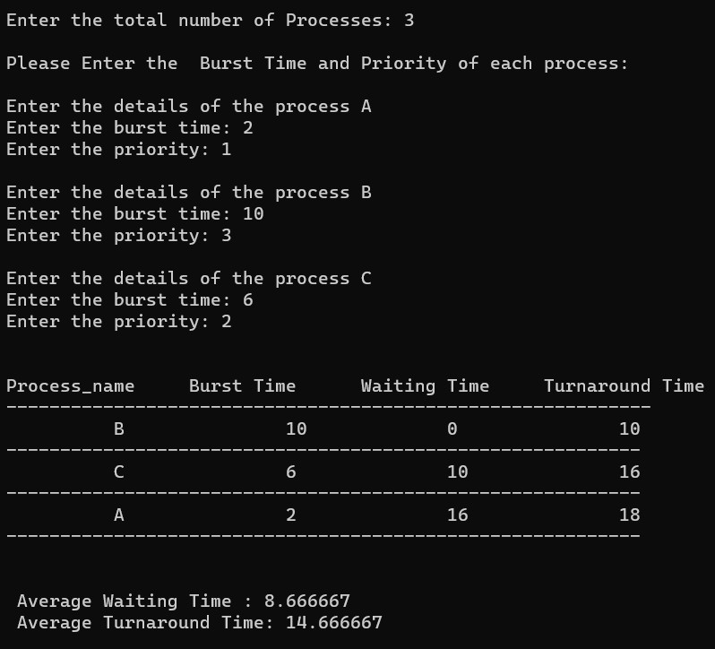

**6. Construct a C program to simulate Round Robin scheduling algorithm with C.**

**Program:-**

#include<stdio.h> #include<conio.h> int main()

{ int i, NOP, sum=0,count=0, y, quant, wt=0, tat=0, at[10], bt[10], temp[10]; float avg_wt, avg_tat; printf(" Total number of process in the system: "); scanf("%d", &NOP); y = NOP;

for(i=0; i<NOP; i++)

{ printf("\n Enter the Arrival and Burst time of the Process[%d]\n", i+1); printf(" Arrival time is: \t"); scanf("%d", &at[i]);

printf(" \nBurst time is: \t"); scanf("%d", &bt[i]); temp[i] =

bt[i]; }

printf("Enter the Time Quantum for the process: \t"); scanf("%d", &quant); printf("\n Process No \t\t Burst Time \t\t TAT \t\t Waiting Time "); for(sum=0, i = 0; y!=0; ) { if(temp[i] <= quant && temp[i] > 0)

{ sum = sum + temp[i]; temp[i] = 0; count=1; } else if(temp[i] > 0)

{ temp[i] = temp[i] - quant; sum

= sum + quant;

}

if(temp[i]==0 && count==1)

{ y--;

printf("\nProcess No[%d] \t\t %d\t\t\t\t %d\t\t\t %d", i+1, bt[i], sum- at[i], sum-

at[i]-bt[i]); wt = wt+sum-at[i]-bt[i]; tat = tat+sum-at[i]; count =0;

} if(i==NOP-1)

{ i=0; } else if(at[i+1]<=sum)

{ i++; } else

{ i=0;

}

} avg_wt = wt * 1.0/NOP; avg_tat = tat * 1.0/NOP;

printf("\n Average Turn Around Time: \t%f", avg_wt); printf("\n

Average Waiting Time: \t%f", avg_tat); getch();

}

**OUTPUT**

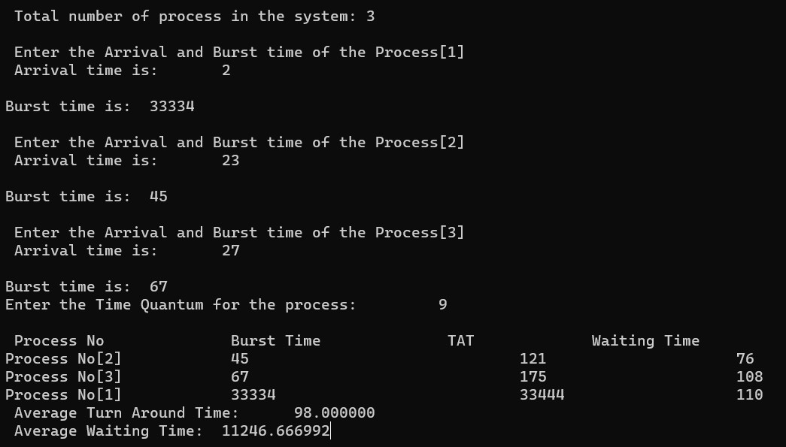

**7. Construct a C program to implement non-preemptive SJF algorithm**

**PROGRAM:**

#include <stdio.h>

int main() {

int at[10], bt[10], pr[10];

int n, i, j, temp, time = 0, count, over = 0, sum_wait = 0, sum_turnaround = 0, start;

float avgwait, avgturn;

printf("Enter the number of processes\n");

scanf("%d", &n);

for (i = 0; i < n; i++) {

printf("Enter the arrival time and execution time for process %d\n", i + 1);

scanf("%d%d", &at[i], &bt[i]);

pr[i] = i + 1;

}

// Sorting based on arrival time

for (i = 0; i < n - 1; i++) {

for (j = i + 1; j < n; j++) {

if (at[i] > at[j]) {

temp = at[i]; at[i] = at[j]; at[j] = temp;

temp = bt[i]; bt[i] = bt[j]; bt[j] = temp;

temp = pr[i]; pr[i] = pr[j]; pr[j] = temp;

}

}

}

printf("\n\nProcess\t| Arrival time\t| Execution time\t| Start time\t| End time\t| Waiting time\t| Turnaround time\n\n");

// Main scheduling logic

while (over < n) {

count = 0;

// Count processes that have arrived

for (i = over; i < n; i++) {

if (at[i] <= time)

count++;

else

break;

}

// Sorting based on execution time (burst time) if multiple processes are available

if (count > 1) {

for (i = over; i < over + count - 1; i++) {

for (j = i + 1; j < over + count; j++) {

if (bt[i] > bt[j]) {

temp = at[i]; at[i] = at[j]; at[j] = temp;

temp = bt[i]; bt[i] = bt[j]; bt[j] = temp;

temp = pr[i]; pr[i] = pr[j]; pr[j] = temp;

}

}

}

}

// Process execution

start = time;

time += bt[over];

printf("p[%d]\t|\t%d\t|\t%d\t|\t%d\t|\t%d\t|\t%d\t|\t%d\n",

pr[over], at[over], bt[over], start, time,

time - at[over] - bt[over], time - at[over]);

sum_wait += time - at[over] - bt[over];

sum_turnaround += time - at[over];

over++;

}

avgwait = (float)sum_wait / (float)n;

avgturn = (float)sum_turnaround / (float)n;

printf("Average waiting time is %.2f\n", avgwait);

printf("Average turnaround time is %.2f\n", avgturn);

return 0;

}}

**OUTPUT**

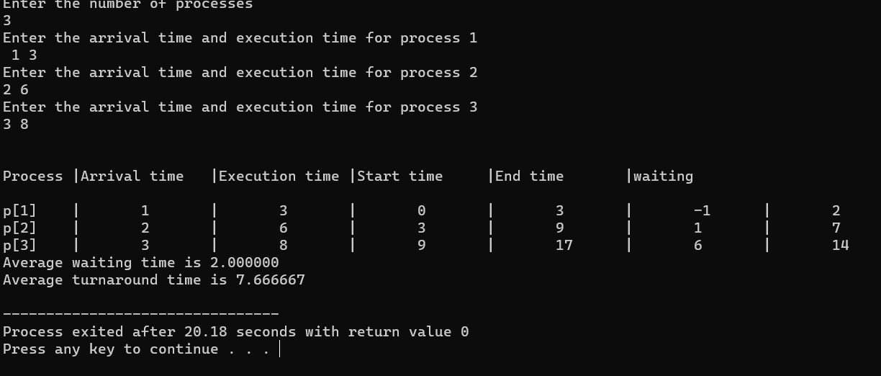

**8. Construct a C program to simulate Round Robin scheduling algorithm with C.**

**PROGRAM:**

#include<stdio.h> #include<conio.h> int main() { int i, NOP, sum=0,count=0, y, quant, wt=0, tat=0, at[10], bt[10], temp[10]; float avg_wt, avg_tat; printf(" Total number of process in the system: "); scanf("%d", &NOP); y = NOP;

for(i=0; i<NOP; i++) { printf("\n Enter the Arrival and Burst time of the Process[%d]\n", i+1); printf(" Arrival time is: \t"); scanf("%d", &at[i]);

scanf("%d", &bt[i]); temp[i] = bt[i]; } printf("Enter the Time Quantum for the process: \t");

scanf("%d", &quant);

printf("\n Process No \t\t Burst Time \t\t TAT \t\t Waiting Time "); for(sum=0, i = 0; y!=0; )

{

if(temp[i] <= quant && temp[i] > 0)

{ sum = sum + temp[i]; temp[i] = 0; count=1; }

else if(temp[i] > 0)

{ temp[i] = temp[i] - quant; sum

= sum + quant;

}

if(temp[i]==0 && count==1)

{ y--;

printf("\nProcess No[%d] \t\t %d\t\t\t\t %d\t\t\t %d", i+1, bt[i], sum- at[i], sum-

at[i]-bt[i]); wt = wt+sum-at[i]-bt[i]; tat

= tat+sum-at[i]; count =0;

}

if(i==NOP-1)

{ i=0;

}

else if(at[i+1]<=sum) {

i++; }

else { i=0; }

}

avg_wt = wt * 1.0/NOP; avg_tat = tat * 1.0/NOP;

printf("\n Average Turn Around Time: \t%f", avg_wt); printf("\n

Average Waiting Time: \t%f", avg_tat); getch();

}

**OUTPUT**

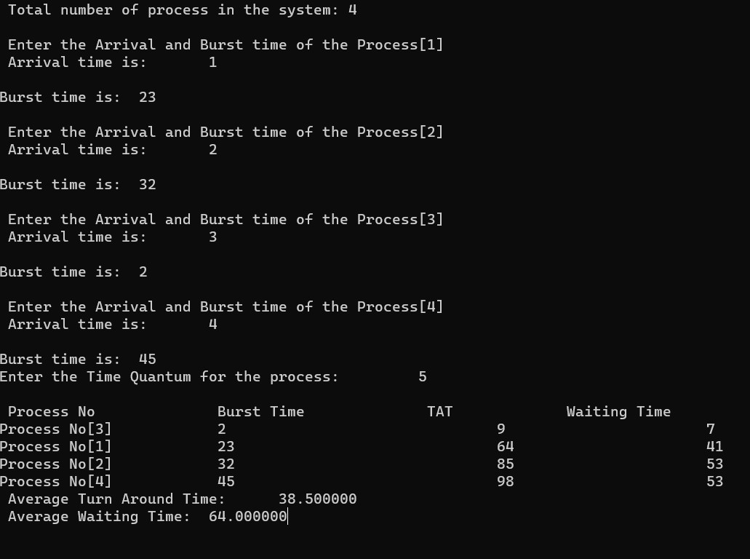

**9. Illustrate the concept of inter-process communication using shared memory with a C program**

**AIM:**

To implement the concept of inter-process communication using shared memory using C programming.

**ALGORITHM:**

1. Create a shared memory segment:

* Use shmget() function to create a new shared memory segment or get the identifier of an existing one.
* Ensure to handle errors if the shared memory creation fails.

2. Attach shared memory to processes:

* Use shmat() function to attach the shared memory segment to the process address space.
* This allows processes to read and write data to the shared memory.

3. Read/Write data in shared memory:

* Processes can read and write data directly to the shared memory location.
* Ensure proper synchronization mechanisms (like semaphores) are used to avoid race conditions and maintain data consistency.

4. Detach shared memory and clean up:

* Use shmdt() function to detach the shared memory segment from the process when done.
* Optionally, remove the shared memory segment using shmctl() with the IPC_RMID command.

**PROGRAM:**

#include <stdio.h>

#include <stdlib.h>

#include <string.h>

#include <unistd.h>

#include <sys/ipc.h>

#include <sys/shm.h>

#define SHM_SIZE 1024 // Size of the shared memory segment int main() { key_t key = ftok("shmfile", 65); // Generate a unique key for the shared

memory segment

// Create a new shared memory segment (or get the identifier of an existing one) int shmid = shmget(key, SHM_SIZE, IPC_CREAT | 0666); if (shmid

== -1) { perror("shmget"); exit(EXIT_FAILURE);

}

// Attach the shared memory segment to the process address space char *shm_ptr = (char*)shmat(shmid, NULL, 0); if

(shm_ptr == (char*)(-1)) { perror("shmat"); exit(EXIT_FAILURE);

}

// Write data to the shared memory strcpy(shm_ptr,

"Hello, shared memory!");

// Detach the shared memory segment from the process if

(shmdt(shm_ptr) == -1) { perror("shmdt"); exit(EXIT_FAILURE);

}

printf("Data written to shared memory: %s\n", shm_ptr);

// Optional: Remove the shared memory segment if

(shmctl(shmid, IPC_RMID, NULL) == -1) { perror("shmctl"); exit(EXIT_FAILURE);

}

return 0;

}

**OUTPUT:**

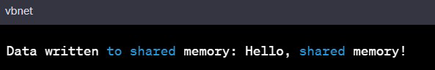

**10. Illustrate the concept of inter-process communication using message queue with a c program**

**PROGRAM :**

#include <stdio.h>

#include <stdlib.h>

#include <string.h>

#include <unistd.h>

#include <sys/types.h>

#include <sys/ipc.h>

#include <sys/msg.h>

struct message { long msg_type;

char msg_text[100];

};

int main() { key_t key = ftok("msgqfile", 65); // Generate a unique key for the message

queue

// Create a new message queue (or get the identifier of an existing one) int msgid = msgget(key, IPC_CREAT | 0666);

if (msgid == -1) { perror("msgget"); exit(EXIT_FAILURE);

}

struct message msg;

msg.msg_type = 1; // Message type (can be any positive number)

// Producer: Send a message to the message queue strcpy(msg.msg_text, "Hello, message queue!"); if (msgsnd(msgid, (void*)&msg, sizeof(msg.msg_text),

IPC_NOWAIT) == -1) { perror("msgsnd"); exit(EXIT_FAILURE);

}

printf("Producer: Data sent to message queue: %s\n", msg.msg_text);

// Consumer: Receive a message from the message queue if (msgrcv(msgid, (void*)&msg, sizeof(msg.msg_text), 1, 0) == -1) { perror("msgrcv"); exit(EXIT_FAILURE);

}

printf("Consumer: Data received from message queue: %s\n",

msg.msg_text);

// Remove the message queue if (msgctl(msgid, IPC_RMID, NULL) == -1) { perror("msgctl"); exit(EXIT_FAILURE);

}

return 0;

}

**OUTPUT :**

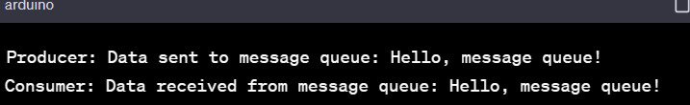

**11. Illustrate the concept of multithreading using a C program**

**PROGRAM :**

#include <stdio.h>

#include <pthread.h>

void* threadFunction(void* arg) { char* message = (char*)arg; printf("%s\n", message);

return NULL;

}

int main() { pthread_t thread1, thread2;

char* message1 = "Hello from Thread 1!"; char* message2 = "Hello from Thread 2!";

// Create threads

pthread_create(&thread1, NULL, threadFunction, (void*)message1); pthread_create(&thread2, NULL, threadFunction, (void*)message2);

// Wait for threads to complete pthread_join(thread1, NULL); pthread_join(thread2, NULL);

return 0;

}

**OUTPUT :**

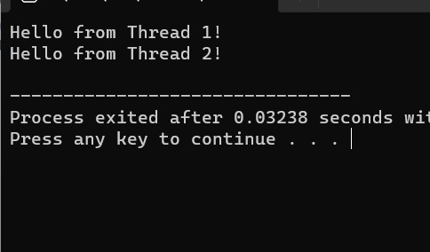

**12. Design a C program to simulate the concept of Dining-Philosophers**

**PROGRAM :**

#include <stdio.h>

#include <stdlib.h>

#include <pthread.h>

#include <unistd.h>

#define NUM_PHILOSOPHERS 5

pthread_mutex_t chopsticks[NUM_PHILOSOPHERS];

void* philosopherLifeCycle(void* arg) { int id =

*((int*)arg); int left_chopstick = id;

int right_chopstick = (id + 1) % NUM_PHILOSOPHERS;

while (1) {

// Think printf("Philosopher %d is thinking...\n", id);

// Pick up chopsticks pthread_mutex_lock(&chopsticks[left_chopstick]);

pthread_mutex_lock(&chopsticks[right_chopstick]);

// Eat printf("Philosopher %d is eating...\n", id);

sleep(rand() % 3 + 1); // Eating time

// Put down chopsticks pthread_mutex_unlock(&chopsticks[left_chopstick]); pthread_mutex_unlock(&chopsticks[right_chopstick]);

// Repeat the cycle

}

}

int main() {

pthread_t philosophers[NUM_PHILOSOPHERS]; int

philosopher_ids[NUM_PHILOSOPHERS];

// Initialize mutex locks

for (int i = 0; i < NUM_PHILOSOPHERS; ++i) {

pthread_mutex_init(&chopsticks[i], NULL);

}

// Create philosopher threads for (int i = 0; i < NUM_PHILOSOPHERS; ++i) { philosopher_ids[i] = i; pthread_create(&philosophers[i], NULL, philosopherLifeCycle,

(void*)&philosopher_ids[i]);

}

// Wait for threads to finish (although they run indefinitely) for (int i =

0; i < NUM_PHILOSOPHERS; ++i) { pthread_join(philosophers[i], NULL);

}

// Destroy mutex locks

for (int i = 0; i < NUM_PHILOSOPHERS; ++i) { pthread_mutex_destroy(&chopsticks[i]); }

return 0;

}

**OUTPUT :**

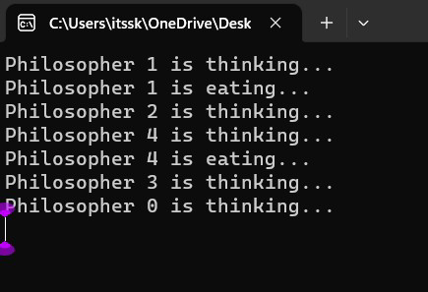

**13. Construct a C program to implement various memory allocation strategies.**

**PROGRAM :**

#include<stdio.h>

void bestfit(int mp[],int p[],int m,int n){ int j=0; for(int i=0;i<n;i++){ if(mp[i]>p[j]){ printf("\n%d fits in %d",p[j],mp[i]); mp[i]=mp[i]-p[j++]; i=i-1;

} }

for(int i=j;i<m;i++)

{

printf("\n%d must wait for its process",p[i]); }

}

void rsort(int a[],int n){ for(int i=0;i<n;i++){ for(int j=0;j<n;j++){ if(a[i]>a[j]){ int t=a[i]; a[i]=a[j]; a[j]=t;

}

}

}

}

void sort(int a[],int n){ for(int i=0;i<n;i++){ for(int j=0;j<n;j++){ if(a[i]<a[j]){ int t=a[i]; a[i]=a[j]; a[j]=t;

}

}

} }

void firstfit(int mp[],int p[],int m,int n){ sort(mp,n); sort(p,m); bestfit(mp,p,m,n);

}

void worstfit(int mp[],int p[],int m,int n){ rsort(mp,n); sort(p,m); bestfit(mp,p,m,n);

} int main(){ int m,n,mp[20],p[20],ch; printf("Number of memory partition : "); scanf("%d",&n); printf("Number of process : "); scanf("%d",&m); printf("Enter the memory partitions : \n"); for(int i=0;i<n;i++){ scanf("%d",&mp[i]);

}

printf("ENter process size : \n"); for(int i=0;i<m;i++){ scanf("%d",&p[i]);

}

printf("1. Firstfit\t2. Bestfit\t3. worstfit\nEnter your choice : "); scanf("%d",&ch); switch(ch){ case 1: bestfit(mp,p,m,n); break; case 2: firstfit(mp,p,m,n); break; case 3: worstfit(mp,p,m,n); break;

default: printf("invalid"); break;

}

}

**OUTPUT :**

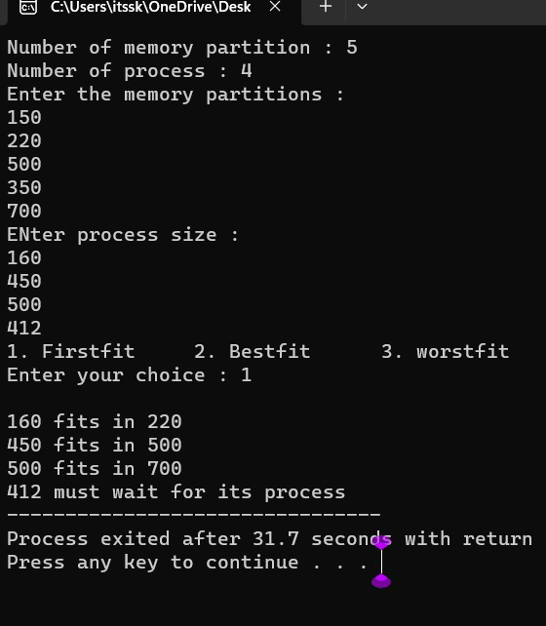

**14. Construct a C program to organize the file using single level directory**

**PROGRAM :**

#include <stdio.h>

#include <stdlib.h>

#include <fcntl.h>

#include <unistd.h>

#define BUFFER_SIZE 4096 void copy(){ const char *sourcefile=

"C:/Users/itssk/OneDrive/Desktop/sasi.txt"; const char *destination_file="C:/Users/itssk/OneDrive/Desktop/sk.txt"; int source_fd = open(sourcefile, O_RDONLY); int dest_fd = open(destination_file, O_WRONLY | O_CREAT | O_TRUNC,

0666); char buffer[BUFFER_SIZE]; ssize_t bytesRead, bytesWritten; while ((bytesRead = read(source_fd, buffer, BUFFER_SIZE)) > 0) { bytesWritten = write(dest_fd, buffer, bytesRead);

}

close(source_fd); close(dest_fd);

printf("File copied successfully.\n");

} void create()

{ char path[100];

FILE *fp; fp=fopen("C:/Users/itssk/OneDrive/Desktop/sasi.txt","w"); printf("file created successfully");

}

int main(){

int n;

printf("1. Create \t2. Copy \t3. Delete\nEnter your choice: " ); scanf("%d",&n); switch(n){

case 1:

create(); break; case 2:

copy(); break; case 3:

remove("C:/Users/itssk/OneDrive/Desktop/sasi.txt"); printf("Deleted successfully");

}}

**OUTPUT :**

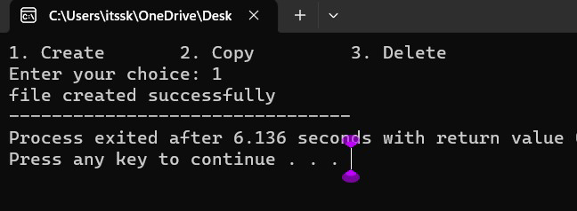

**15. Design a C program to organize the file using two level directory structure.**

**PROGRAM :**

#include <stdio.h>

#include <stdlib.h>

#include <string.h> int main() { char mainDirectory[] = "C:/Users/itssk/OneDrive/Desktop"; char subDirectory[] = "os";

char fileName[] = "example.txt"; char filePath[200]; char mainDirPath[200];

snprintf(mainDirPath, sizeof(mainDirPath), "%s/%s/", mainDirectory, subDirectory); snprintf(filePath, sizeof(filePath), "%s%s", mainDirPath, fileName); FILE *file

= fopen(filePath, "w"); if (file == NULL) { printf("Error creating file.\n"); return 1;

} fprintf(file, "This is an example file content."); printf("File created successfully: %s\n"); }

**OUTPUT :**

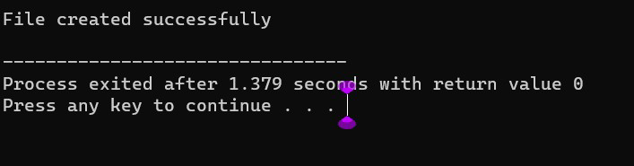

**16. Develop a C program for implementing random access file for processing the employee details**

**PROGRAM :**

#include <stdio.h> #include <stdlib.h> struct Employee {

int empId; char empName[50]; float empSalary;};

int main() { FILE *filePtr; struct Employee emp; filePtr = fopen("employee.dat", "rb+"); if

(filePtr == NULL) { filePtr = fopen("employee.dat", "wb+"); if

(filePtr == NULL) { printf("Error creating the file.\n"); return 1; }

} int choice; do {

| printf("\nEmployee Database printf("1. Add Employee\n"); | Menu:\n"); |
| --- | --- |
| printf("2. Display Employee | Details\n"); |
| printf("3. Update Employee | Details\n"); |

printf("4. Exit\n"); printf("Enter your choice: "); scanf("%d", &choice); switch

(choice) { case 1:

printf("Enter Employee ID: "); scanf("%d",

&emp.empId); printf("Enter Employee

Name: ");

scanf("%s", emp.empName); printf("Enter Employee Salary: "); scanf("%f", &emp.empSalary);

fseek(filePtr, (emp.empId - 1) * sizeof(struct Employee),

SEEK_SET); fwrite(&emp, sizeof(struct Employee), 1, filePtr); printf("Employee details added successfully.\n"); break;

case 2:

printf("Enter Employee ID to display: "); scanf("%d", &emp.empId);

fseek(filePtr, (emp.empId - 1) * sizeof(struct Employee),

SEEK_SET);

fread(&emp, sizeof(struct Employee), 1, filePtr); printf("Employee ID: %d\n", emp.empId); printf("Employee Name: %s\n", emp.empName); printf("Employee Salary:

%.2f\n", emp.empSalary); break; case 3:

printf("Enter Employee ID to update: "); scanf("%d", &emp.empId);

fseek(filePtr, (emp.empId - 1) * sizeof(struct Employee),

SEEK_SET);

fread(&emp, sizeof(struct Employee), 1, filePtr); printf("Enter Employee Name: "); scanf("%s", emp.empName); printf("Enter Employee Salary: "); scanf("%f", &emp.empSalary);

fseek(filePtr, (emp.empId - 1) * sizeof(struct Employee),

SEEK_SET);

fwrite(&emp, sizeof(struct Employee), 1, filePtr); printf("Employee details updated successfully.\n"); break;

case 4:

break;

default:

printf("Invalid choice. Please try again.\n"); }

} while (choice != 4); fclose(filePtr); return 0;

**OUTPUT :**

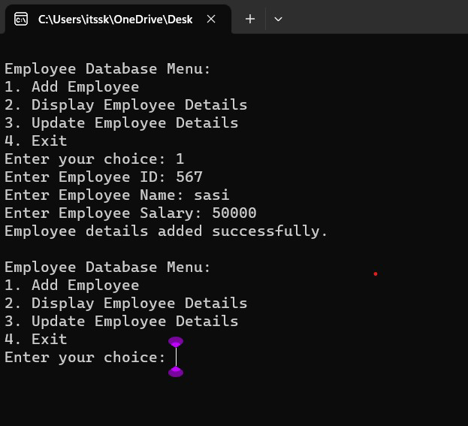

**17. Illustrate the deadlock avoidance concept by simulating Banker’s algorithm using C.**

**PROGRAM :**

#include <stdio.h>

#define MAX_PROCESSES 5 #define MAX_RESOURCES 3 int

is_safe(); int available[MAX_RESOURCES] = {3, 3, 2}; // Available instances of each resource

int maximum[MAX_PROCESSES][MAX_RESOURCES] = {{7, 5, 3},

{3, 2, 2}, {9, 0, 2}, {2, 2, 2}, {4, 3, 3}};

int allocation[MAX_PROCESSES][MAX_RESOURCES] = {{0, 1, 0},

{2, 0, 0}, {3, 0, 2}, {2, 1, 1}, {0, 0, 2}};

int request_resources(int process_num, int request[]) {

// Check if request can be granted for (int i = 0; i < MAX_RESOURCES; i++) {

if (request[i] > available[i] || request[i] > maximum[process_num][i]

- allocation[process_num][i])

return 0; // Request cannot be granted

}

// Try allocating resources temporarily for (int i = 0; i < MAX_RESOURCES; i++) { available[i] -= request[i]; allocation[process_num][i] += request[i];

// Update maximum and need matrix if request is granted maximum[process_num][i] -= request[i];

}

// Check if system is in safe state after allocation if

(is_safe()) { return 1; // Request is granted

} else {

// Roll back changes if not safe for (int i = 0; i < MAX_RESOURCES; i++) { available[i] += request[i]; allocation[process_num][i] -= request[i]; maximum[process_num][i] += request[i];

}

return 0; // Request is denied

}

}

int is_safe() {

int work[MAX_RESOURCES];

int finish[MAX_PROCESSES] = {0};

// Initialize work array

for (int i = 0; i < MAX_RESOURCES; i++) { work[i] = available[i];

}

// Check if processes can finish int count = 0; while (count < MAX_PROCESSES) { int found = 0; for (int i = 0; i < MAX_PROCESSES; i++) { if

(finish[i] == 0) { int j;

for (j = 0; j < MAX_RESOURCES; j++) { if (maximum[i][j] - allocation[i][j] > work[j]) break;

}

if (j == MAX_RESOURCES) {

// Process can finish, update work and mark as finished for (int k

= 0; k < MAX_RESOURCES; k++) { work[k] += allocation[i][k];

} finish[i] = 1; found = 1; count++;

}

} }

if (found == 0) { return 0; // No process can finish, not safe state }

}

return 1; // All processes can finish, safe state

}

int main() {

int process_num, request[MAX_RESOURCES];

printf("Enter process number (0 to 4): "); scanf("%d",

&process_num);

printf("Enter resource request (e.g., 0 1 0): "); for (int i = 0; i < MAX_RESOURCES; i++) {

scanf("%d", &request[i]);

}

if (request_resources(process_num, request)) {

printf("Request granted.\n");

} else { printf("Request denied. System is not in safe state.\n");

} return 0;

**OUTPUT :**

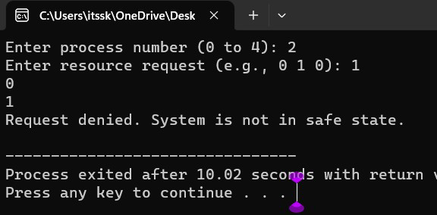

**18. Construct a C program to simulate producer consumer problem using semaphores.**

**PROGRAM :**

#include <stdio.h> #include

<pthread.h> #include

<semaphore.h>

#include<Windows.h>

#define BUFFER_SIZE 5

#define MAX_ITEMS 10 // Maximum number of items to be produced/consumed

int buffer[BUFFER_SIZE]; sem_t empty, full;

int produced_items = 0, consumed_items = 0;

void* producer(void* arg) { while (produced_items < MAX_ITEMS) { sem_wait(&empty);

// Critical section: add item to buffer for (int i = 0; i < BUFFER_SIZE; ++i) { if

(buffer[i] == 0) { buffer[i] = produced_items + 1; printf("Produced: %d\n", buffer[i]); produced_items++; break;

} } sem_post(&full);

Sleep(1); // Sleep for a while

} return NULL;

}

void* consumer(void* arg) {

while (consumed_items < MAX_ITEMS) {

sem_wait(&full);

// Critical section: remove item from buffer for (int i = 0; i < BUFFER_SIZE; ++i) { if (buffer[i] != 0) { printf("Consumed: %d\n", buffer[i]); buffer[i] = 0;

consumed_items++; break;

} }

sem_post(&empty); Sleep(2); // Sleep for a while

} return NULL;

}

int main() {

pthread_t producer_thread, consumer_thread;

sem_init(&empty, 0, BUFFER_SIZE); sem_init(&full, 0, 0);

// Create producer and consumer threads pthread_create(&producer_thread, NULL, producer, NULL); pthread_create(&consumer_thread, NULL, consumer, NULL);

// Wait for threads to finish pthread_join(producer_thread, NULL); pthread_join(consumer_thread, NULL);

// Destroy semaphores sem_destroy(&empty); sem_destroy(&full);

return 0;

}

**OUTPUT :**

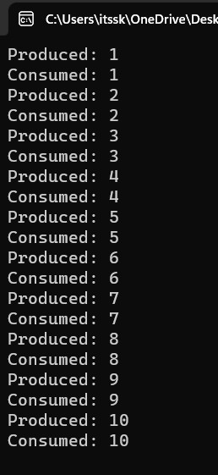

**19. design a C program to implement process synchronization using mutex locks.**

**PROGRAM :**

#include <stdio.h>

#include <pthread.h>

// Shared variables int counter = 0;

pthread_mutex_t mutex;

// Function to be executed by threads void

*threadFunction(void *arg) {

int i;

for (i = 0; i < 1000000; ++i) { } return NULL;

}

int main() {pthread_mutex_init(&mutex, NULL);

pthread_t thread1, thread2;

pthread_create(&thread1, NULL, threadFunction, NULL); pthread_create(&thread2, NULL, threadFunction, NULL);

// Wait for the threads to finish pthread_join(thread1, NULL); pthread_join(thread2, NULL);

// Destroy the mutex pthread_mutex_destroy(&mutex);

// Print the final value of the counter printf("Final counter value: %d\n", counter);

return 0;

}

**OUTPUT :**

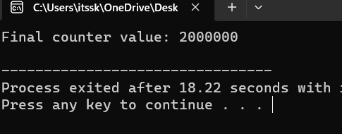

**20. Construct a C program to simulate Reader-Writer problem using semaphores**

**PROGRAM :**

#include <stdio.h> #include

<pthread.h> #include

<semaphore.h>

sem_t mutex, writeBlock;

int data = 0, readersCount = 0;

void *reader(void *arg) { int i=0;

while (i<10) {

sem_wait(&mutex); readersCount++; if (readersCount == 1) {

sem_wait(&writeBlock);

}

sem_post(&mutex);

// Reading operation

printf("Reader reads data: %d\n", data);

sem_wait(&mutex); readersCount--; if (readersCount == 0) {

sem_post(&writeBlock);

} sem_post(&mutex); i++;

}

}

void *writer(void *arg) { int i=0;

while (i<10) {

sem_wait(&writeBlock);

// Writing operation data++; printf("Writer writes data: %d\n", data);

sem_post(&writeBlock); i++;

}

}

int main() {

pthread_t readers, writers; sem_init(&mutex, 0, 1);

sem_init(&writeBlock, 0, 1); pthread_create(&readers, NULL, reader, NULL); pthread_create(&writers, NULL, writer, NULL); pthread_join(readers, NULL); pthread_join(writers, NULL); sem_destroy(&mutex); sem_destroy(&writeBlock);

return 0;

}

**OUTPUT :**

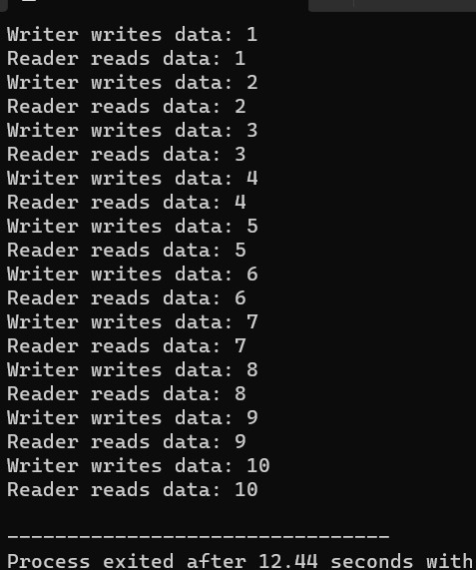

**21. Develop a C program to implement worst fit algorithm of memory management.**

**PROGRAM:**

#include <stdio.h>

#define MAX_MEMORY 1000 int memory[MAX_MEMORY];

// Function to initialize memory void initializeMemory() {

for (int i = 0; i < MAX_MEMORY; i++) { memory[i] = -1; // -1 indicates that the memory is unallocated

}

}

// Function to display memory status void

displayMemory() { int i, j;

int count = 0; printf("Memory Status:\n");

for (i = 0; i < MAX_MEMORY; i++) { if (memory[i] == -1) {

count++;

j = i;

while (memory[j] == -1 && j < MAX_MEMORY) { j++;

}

printf("Free memory block %d-%d\n", i, j - 1); i = j - 1;

}

}

if (count == 0) { printf("No free memory available.\n");

}

}

// Function to allocate memory using worst-fit algorithm void allocateMemory(int processId, int size) { int start = -1; int blockSize = 0;

for (int i = 0; i < MAX_MEMORY; i++) { if

(memory[i] == -1) { if (blockSize == 0) { start = i; } blockSize++;

} else { blockSize = 0;

}

if (blockSize >= size) { break;

}

}

if (blockSize >= size) { for (int i = start; i < start + size; i++) { memory[i] = processId;

}

printf("Allocated memory block %d-%d to Process %d\n", start, start + size - 1,

processId);

} else { printf("Memory allocation for Process %d failed (not enough contiguous

memory).\n", processId);

}

}

// Function to deallocate memory void deallocateMemory(int processId) { for (int i = 0; i < MAX_MEMORY; i++) { if

(memory[i] == processId) { memory[i] = -1;

} }

printf("Memory released by Process %d\n", processId); }

int main() { initializeMemory(); displayMemory();

allocateMemory(1, 200); displayMemory();

allocateMemory(2, 300); displayMemory();

deallocateMemory(1); displayMemory();

allocateMemory(3, 400); displayMemory();

return 0;

}

**OUTPUT:**

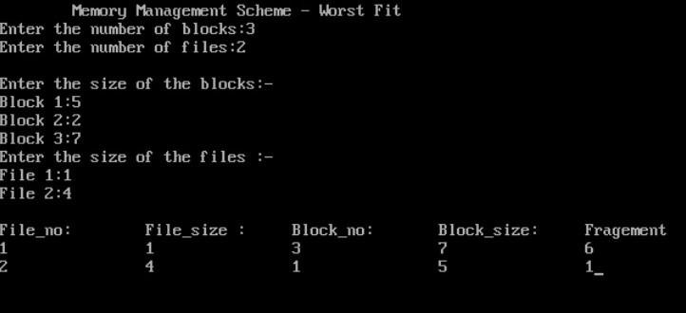

**22. Construct a C program to implement best fit algorithm of memory management.**

**PROGRAM:**

#include <stdio.h>

#define MAX_MEMORY 1000 int memory[MAX_MEMORY];

// Function to initialize memory void initializeMemory() {

for (int i = 0; i < MAX_MEMORY; i++) { memory[i] = -1; // -1 indicates that the memory is unallocated

}

}

// Function to display memory status void

displayMemory() { int i, j;

int count = 0; printf("Memory Status:\n");

for (i = 0; i < MAX_MEMORY; i++) { if (memory[i] == -1) {

count++;

j = i;

while (memory[j] == -1 && j < MAX_MEMORY) { j++;

}

printf("Free memory block %d-%d\n", i, j - 1); i = j - 1;

}

}

if (count == 0) { printf("No free memory available.\n");

}

}

// Function to allocate memory using best-fit algorithm void allocateMemory(int processId, int size) { int start = -1;

int blockSize = MAX_MEMORY; int

bestStart = -1;

int bestSize = MAX_MEMORY;

for (int i = 0; i < MAX_MEMORY; i++) { if

(memory[i] == -1) { if (blockSize == MAX_MEMORY) { start = i;

}

blockSize++;

} else { if (blockSize >= size && blockSize < bestSize) { bestSize

= blockSize; bestStart = start;

}

blockSize = 0;

}

}

if (bestSize >= size) { for (int i = bestStart; i < bestStart + size; i++) { memory[i] = processId;

}

printf("Allocated memory block %d-%d to Process %d\n", bestStart, bestStart +

size - 1, processId);

} else { printf("Memory allocation for Process %d failed (not enough contiguous

memory).\n", processId);

}

}

// Function to deallocate memory void deallocateMemory(int processId) { for (int i = 0; i < MAX_MEMORY; i++) { if

(memory[i] == processId) { memory[i] = -1;

} }

printf("Memory released by Process %d\n", processId); }

int main() { initializeMemory(); displayMemory();

allocateMemory(1, 200); displayMemory();

allocateMemory(2, 300); displayMemory();

deallocateMemory(1); displayMemory();

allocateMemory(3, 400); displayMemory();

return 0;

}

**OUTPUT:**

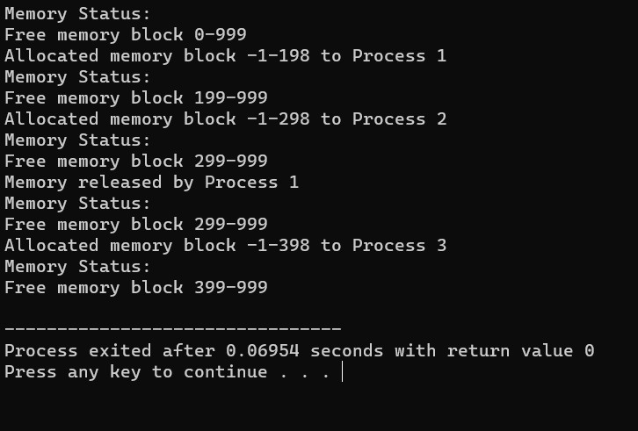

**23. Construct a C program to implement first fit algorithm of memory management.**

**PROGRAM:**

#include <stdio.h>

#define MAX_MEMORY 1000 int memory[MAX_MEMORY];

// Function to initialize memory void initializeMemory() {

for (int i = 0; i < MAX_MEMORY; i++) { memory[i] = -1; // -1 indicates that the memory is unallocated }

}

// Function to display memory status void

displayMemory() { int i, j;

int count = 0; printf("Memory Status:\n"); for (i = 0; i < MAX_MEMORY; i++) { if (memory[i] == -1) {

count++;

j = i;

while (memory[j] == -1 && j < MAX_MEMORY) { j++;

}

printf("Free memory block %d-%d\n", i, j - 1); i = j - 1;

}

}

if (count == 0) { printf("No free memory available.\n");

}

}

// Function to allocate memory using first-fit algorithm void allocateMemory(int processId, int size) { int start = -1; int blockSize = 0;

for (int i = 0; i < MAX_MEMORY; i++) { if

(memory[i] == -1) { if (blockSize == 0) { start = i; } blockSize++;

} else {

blockSize = 0;

}

if (blockSize >= size) { break;

}

}

if (blockSize >= size) { for (int i = start; i < start + size; i++) { memory[i] = processId;

}

printf("Allocated memory block %d-%d to Process %d\n", start, start + size - 1,

processId);

} else { printf("Memory allocation for Process %d failed (not enough contiguous

memory).\n", processId);

}

}

// Function to deallocate memory void deallocateMemory(int processId) { for (int i = 0; i < MAX_MEMORY; i++) { if

(memory[i] == processId) { memory[i] = -1;

} }

printf("Memory released by Process %d\n", processId); }

int main() { initializeMemory();

displayMemory();

allocateMemory(1, 200); displayMemory();

allocateMemory(2, 300); displayMemory();

deallocateMemory(1); displayMemory();

allocateMemory(3, 400); displayMemory();

return 0;

}

**OUTPUT:**

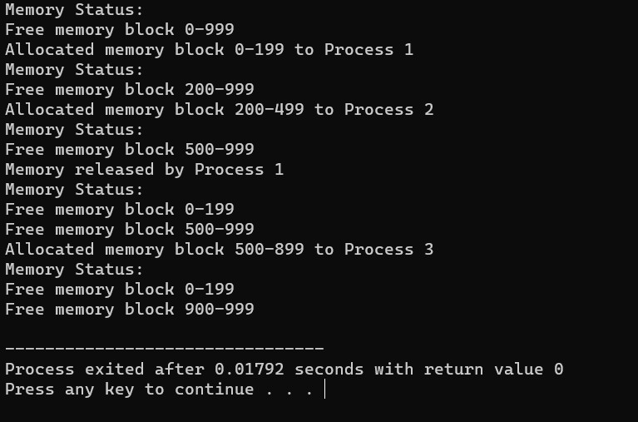

**24. Design a C program to demonstrate UNIX system calls for file management.**

**PROGRAM:**

#include <stdio.h>

#include <stdlib.h>

#include <unistd.h>

#include <fcntl.h>

#include <sys/types.h>

#include <sys/stat.h>

int main() { int fd;

char buffer[100];

// Creating a new file

fd = creat("sample.txt", S_IRWXU); if (fd

== -1) { perror("create"); exit(1);

} else { printf("File 'sample.txt' created successfully.\n"); close(fd);

}

// Opening an existing file for writing

fd = open("sample.txt", O_WRONLY | O_APPEND); if (fd ==

-1) { perror("open"); exit(1);

} else { printf("File 'sample.txt' opened for writing.\n");

}

// Writing data to the file write(fd,

"Hello, World!\n", 14);

printf("Data written to 'sample.txt'.\n"); close(fd);

// Opening the file for reading

fd = open("sample.txt", O_RDONLY); if (fd

== -1) { perror("open"); exit(1);

} else { printf("File 'sample.txt' opened for reading.\n"); }

// Reading data from the file

int bytesRead = read(fd, buffer, sizeof(buffer)); if

(bytesRead == -1) { perror("read"); exit(1);

} else { printf("Data read from 'sample.txt':\n"); write(STDOUT_FILENO, buffer, bytesRead);

} close(fd);

// Deleting the file if (remove("sample.txt") == -1) { perror("remove");

exit(1);

} else { printf("File 'sample.txt' deleted.\n"); }

return 0;

}

**OUTPUT:**

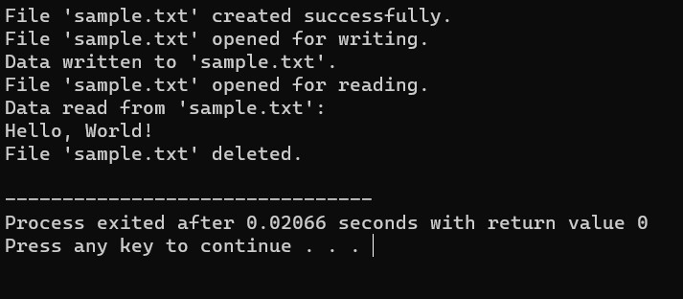

**25) Construct a C program to implement the I/O system calls of UNIX (fcntl, seek, stat, opendir, readdir)**

**PROGRAM:**

#include<stdio.h>

#include<fcntl.h> #include<errno.h> extern int errno; int

main()

{

int fd = open("foo.txt", O_RDONLY | O_CREAT);

printf("fd = %d\n", fd); if (fd ==-1)

{ printf("Error Number % d\n", errno); perror("Program");

} return 0;

}

**OUTPUT:**

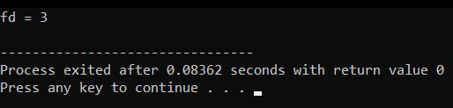

**26) Construct a C program to implement the file management operations.**

**PROGRAM:**

#include <stdio.h>

#include <stdlib.h> int main() {

FILE *file; file = fopen("example.txt", "w"); if

(file == NULL) { printf("Error opening the file for writing.\n"); return 1; }

fprintf(file, "Hello, World!\n");

fprintf(file, "This is a C file management example.\n"); fclose(file);

file = fopen("example.txt", "r"); if

(file == NULL) { printf("Error opening the file for reading.\n"); return 1; } char buffer[100];

while (fgets(buffer, sizeof(buffer), file) != NULL) { printf("%s", buffer);

}

fclose(file);

return 0;

}

**OUTPUT:**

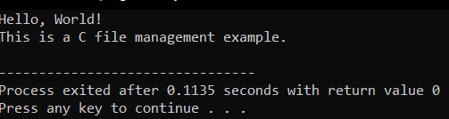

**27) Develop a C program for simulating the function of ls UNIX Command.**

**PROGRAM:**

#include<stdio.h>

#include<dirent.h> int main()

{ char fn[10], pat[10], temp[200]; FILE

*fp;

printf("\n Enter file name : "); scanf("%s", fn); printf("Enter the pattern: "); scanf("%s", pat); fp = fopen(fn, "r"); while (!feof(fp)) { fgets(temp, sizeof(fp), fp); if (strcmp(temp, pat)) printf("%s", temp);

} fclose(fp); return 1;

}

**OUTPUT:**

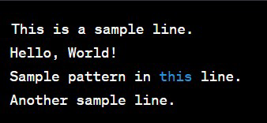

**28) Write a C program for simulation of GREP UNIX command.**

**PROGRAM :**

#include <stdio.h>

#include <stdlib.h>

#include <string.h>

#define MAX_LINE_LENGTH 1024

void searchFile(const char *pattern, const char *filename)

{

FILE *file = fopen(filename, "r"); if (file == NULL) { perror("Error opening file"); exit(1);

}

char line[MAX_LINE_LENGTH]; while

(fgets(line, sizeof(line), file)) { if (strstr(line, pattern) != NULL) { printf("%s", line);

} } fclose(file);

}

int main(int argc, char *argv[]) { if

(argc != 3) { fprintf(stderr, "Usage: %s <pattern> <filename>\n", argv[0]); return 1;

}

const char *pattern = argv[1]; const char *filename = argv[2]; searchFile(pattern, filename); return 0;

}

**OUTPUT:**

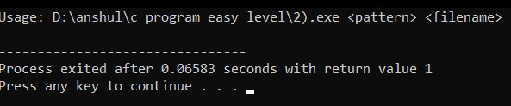

**29) Write a C program to simulate the solution of Classical Process**

**Synchronization Problem**

**PROGRAM:**

#include <stdio.h>

#include <stdlib.h> int mutex = 1;

int full = 0; int empty = 10, x = 0; void producer()

{

--mutex; ++full; --empty; x++;

printf("\nProducer produces" "item %d", x);

++mutex;

}

void consumer()

{

--mutex;

--full;

++empty;

printf("\nConsumer consumes " "item %d",

x);

x--;

++mutex;

} int main()

{ int n, i;

printf("\n1. Press 1 for Producer"

"\n2. Press 2 for Consumer" "\n3.

Press 3 for Exit");

#pragma omp critical for (i

= 1; i > 0; i++)

{ printf("\nEnter your choice:"); scanf("%d", &n); switch (n) { case 1:

if ((mutex == 1) && (empty != 0)) { producer();

} else

{ printf("Buffer is full!");

} break;

case 2:

if ((mutex == 1) && (full != 0)) { consumer();

} else { printf("Buffer is empty!");

} break;

case 3: exit(0); break;

}

}

}

**OUTPUT:**

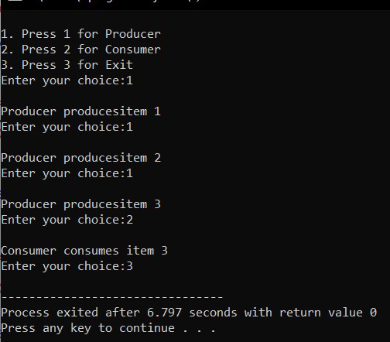

**30. Write C programs to demonstrate the following thread related concepts.**

**PROGRAM:**

#include <pthread.h>

#include <stdio.h> #include <stdlib.h> void* func(void* arg)

{ pthread_detach(pthread_self()); printf("Inside the thread\n"); pthread_exit(NULL);

} void fun()

{ pthread_t ptid;

pthread_create(&ptid, NULL, &func, NULL);

printf("This line may be printed"

" before thread terminates\n"); if(pthread_equal(ptid, pthread_self()))

{ printf("Threads are equal\n");

}

else printf("Threads are not equal\n");

pthread_join(ptid, NULL); printf("This line will be printed" " after thread ends\n");

pthread_exit(NULL);

}

int main()

{ fun(); return 0;

}

**OUTPUT:**

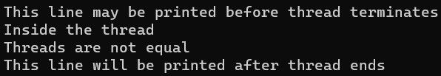

**31. Construct a C program to simulate the First in First Out paging technique of memory management.**

**PROGRAM:**

#include <stdio.h>

#define MAX_FRAMES 3 // Maximum number of frames in memory

void printFrames(int frames[], int n) { for

(int i = 0; i < n; i++) { if (frames[i] == -1) { printf(" - ");

} else { printf(" %d ", frames[i]);

} } printf("\n");

}

int main() { int referenceString[] = {7, 0, 1, 2, 0, 3, 0, 4, 2, 3, 0, 3, 2}; int n = sizeof(referenceString) / sizeof(referenceString[0]); int frames[MAX_FRAMES];

int framePointer = 0; // Points to the current frame to be replaced

for (int i = 0; i < MAX_FRAMES; i++)

{ frames[i] = -1; // Initialize all frames to -1 (indicating empty)

}

printf("Reference String: "); for

(int i = 0; i < n; i++) { printf("%d ", referenceString[i]);

}printf("\n\n");

printf("Page Replacement Order:\n"); for (int i = 0; i < n; i++) { int page = referenceString[i]; int pageFound = 0;

// Check if the page is already in memory for (int j

= 0; j < MAX_FRAMES; j++) { if (frames[j] == page) {

pageFound = 1; break;

}

}

if (!pageFound) {

printf("Page %d -> ", page); frames[framePointer] = page; framePointer = (framePointer + 1) % MAX_FRAMES; printFrames(frames, MAX_FRAMES);

}

}

return 0;

}

**OUTPUT:** 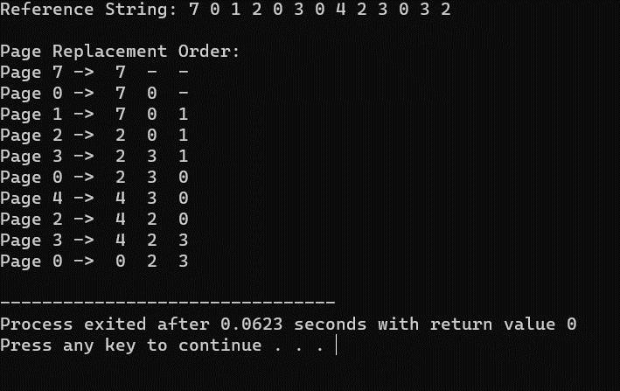

**32. Construct a C program to simulate the Least Recently Used paging technique of memory management.**

**PROGRAM:**

#include <stdio.h>

#include <stdlib.h>

#define MAX_FRAMES 3

void printFrames(int frames[], int n) { for

(int i = 0; i < n; i++) { if (frames[i] == -1) { printf(" - ");

} else { printf(" %d ", frames[i]);

}

}

printf("\n");

}

int main() {

int frames[MAX_FRAMES]; int usageHistory[MAX_FRAMES]; // To store the usage history of pages for (int i = 0; i < MAX_FRAMES; i++) { frames[i] = -1; // Initialize frames to -1 (empty) usageHistory[i] = 0; // Initialize usage history

}

int pageFaults = 0; int referenceString[] = {7, 0, 1, 2, 0, 3, 0, 4, 2, 3, 0, 3, 2}; int n = sizeof(referenceString) / sizeof(referenceString[0]);

printf("Reference String: "); for

(int i = 0; i < n; i++) { printf("%d ", referenceString[i]);

} printf("\n\n"); printf("Page Replacement Order:\n"); for

(int i = 0; i < n; i++) { int page = referenceString[i]; int

pageFound = 0;

// Check if the page is already in memory (a page hit) for (int j

= 0; j < MAX_FRAMES; j++) { if (frames[j] == page) { pageFound = 1;

// Update the usage history by incrementing other pages for (int k

= 0; k < MAX_FRAMES; k++) { if (k != j) {

usageHistory[k]++;

}

}

usageHistory[j] = 0; // Reset the usage counter for the used page break;

}

}

if (!pageFound) {

printf("Page %d -> ", page);

// Find the page with the maximum usage counter (least recently used) int lruPage = 0;

for (int j = 1; j < MAX_FRAMES; j++) { if (usageHistory[j] > usageHistory[lruPage]) { lruPage = j;

}

}

int replacedPage = frames[lruPage]; frames[lruPage] = page;

usageHistory[lruPage] = 0;

if (replacedPage != -1) { printf("Replace %d with %d: ", replacedPage, page);

} else { printf("Load into an empty frame: ");

}

printFrames(frames, MAX_FRAMES); pageFaults++;

}

}

printf("\nTotal Page Faults: %d\n", pageFaults);

return 0;

}

**OUTPUT:**

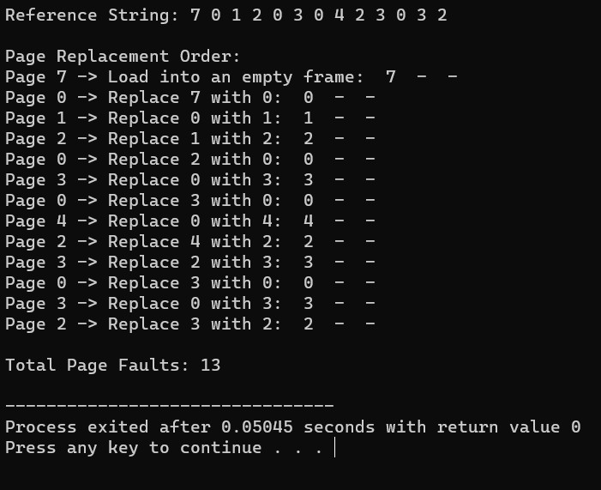

**33. Construct a C program to simulate the optimal paging technique of memory management**

**PROGRAM:**

#include <stdio.h>

#include <stdlib.h>

#define MAX_FRAMES 3

void printFrames(int frames[], int n) { for

(int i = 0; i < n; i++) { if (frames[i] == -1) { printf(" - ");

} else { printf(" %d ", frames[i]);

}

}

printf("\n");

}

int main() {

int frames[MAX_FRAMES];

for (int i = 0; i < MAX_FRAMES; i++) { frames[i] = -1;

// Initialize frames to -1 (empty)

}

int pageFaults = 0; int referenceString[] = {7, 0, 1, 2, 0, 3, 0, 4, 2, 3, 0, 3, 2}; int n = sizeof(referenceString) / sizeof(referenceString[0]);

printf("Reference String: "); for

(int i = 0; i < n; i++) { printf("%d ", referenceString[i]);

} printf("\n\n"); printf("Page Replacement Order:\n"); for

(int i = 0; i < n; i++) { int page = referenceString[i];

int pageFound = 0;

// Check if the page is already in memory (a page hit) for (int j

= 0; j < MAX_FRAMES; j++) { if (frames[j] == page) {

pageFound = 1; break;

}

}

if (!pageFound) { printf("Page %d -> ", page);

int optimalPage = -1; int

farthestDistance = 0;

for (int j = 0; j < MAX_FRAMES; j++) { int

futureDistance = 0; for (int k = i + 1; k < n; k++) { if (referenceString[k] == frames[j]) { break;

}

futureDistance++;

}

if (futureDistance > farthestDistance) {

farthestDistance = futureDistance; optimalPage = j;

}

}

frames[optimalPage] = page;

printFrames(frames, MAX_FRAMES); pageFaults++;

}

}

printf("\nTotal Page Faults: %d\n", pageFaults);

return 0;

}

**OUTPUT**

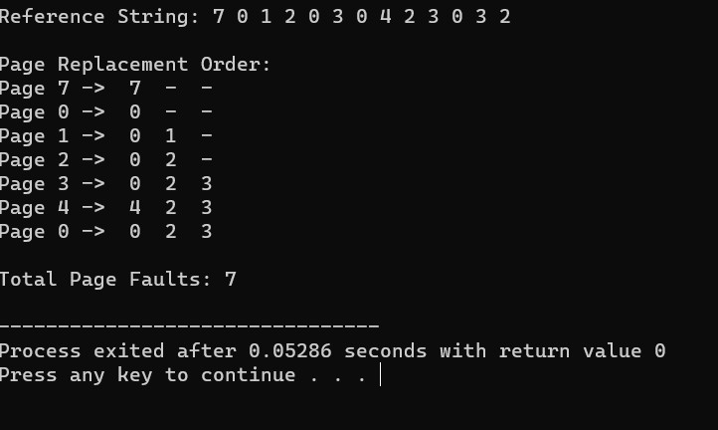

**34. Consider a file system where the records of the file are stored one after another both physically and logically. A record of the file can only be accessed by reading all the previous records. Design a C program to simulate the file allocation strategy.**

**PROGRAM:**

#include <stdio.h>

#include <stdlib.h>

// Structure to represent a record struct

Record { int recordNumber;

char data[256]; // Adjust the size as needed for your records

};

int main() { FILE *file; struct Record record; int recordNumber;

// Open or create a file in write mode (for writing records) file = fopen("sequential_file.txt", "w"); if (file == NULL) { printf("Error opening the file.\n");

return 1;

}

// Write records sequentially to the file

printf("Enter records (Enter '0' as record number to exit):\n"); while (1)

{ printf("Record Number: "); scanf("%d",

&record.recordNumber); if

(record.recordNumber == 0) { break;

}

// Input data for the record printf("Data: ");

scanf(" %[^\n]", record.data);

// Write the record to the file

fwrite(&record, sizeof(struct Record), 1, file);

}

fclose(file);

// Reopen the file in read mode (for reading records) file = fopen("sequential_file.txt", "r"); if (file == NULL) { printf("Error opening the file.\n"); return 1;

}

// Read a specific record from the file while

(1) { printf("Enter the record number to read (0 to exit): "); scanf("%d", &recordNumber); if (recordNumber == 0) {

break;

}

// Read and display records up to the requested record while

(fread(&record, sizeof(struct Record), 1, file)) { printf("Record Number: %d\n", record.recordNumber); printf("Data: %s\n", record.data); if (record.recordNumber == recordNumber) { break; }

}

rewind(file); // Reset the file pointer to the beginning of the file

}

fclose(file); return 0;

}

**OUTPUT:**

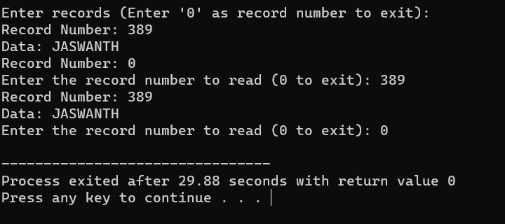

**35. Consider a file system that brings all the file pointers together into an index block. The with entry in the index block points to the ith block of the file. Design a C program to simulate the file allocation strategy.**

**PROGRAM:**

#include <stdio.h>

#include <stdlib.h>

// Structure to represent a block struct Block {int blockNumber;

char data[256]; // Adjust the size as needed for your blocks

};

int main() { FILE *file; struct Block block; int blockNumber;

// Create an index block that contains pointers to data blocks int indexBlock[100] = {0}; // Adjust the size as needed

// Open or create a file in write mode (for writing blocks) file =

fopen("indexed_file.txt", "w"); if (file == NULL) { printf("Error opening the file.\n"); return 1;

}

// Write blocks and update the index block

printf("Enter blocks (Enter '0' as block number to exit):\n"); while (1)

{ printf("Block Number: "); scanf("%d", &block.blockNumber); if

(block.blockNumber == 0) { break;

}

// Input data for the block printf("Data: ");

scanf(" %[^\n]", block.data);

// Write the block to the file

fwrite(&block, sizeof(struct Block), 1, file);

// Update the index block with the pointer to the data block indexBlock[block.blockNumber] = ftell(file) - sizeof(struct Block);

}

fclose(file);

// Reopen the file in read mode (for reading blocks) file = fopen("indexed_file.txt", "r"); if (file == NULL) { printf("Error opening the file.\n"); return 1;

}

// Read a specific block from the file while

(1) { printf("Enter the block number to read (0 to exit): "); scanf("%d", &blockNumber); if (blockNumber == 0) {

break;

}

if (indexBlock[blockNumber] == 0) {

printf("Block not found.\n");

} else {

// Seek to the data block using the index block fseek(file, indexBlock[blockNumber], SEEK_SET); fread(&block, sizeof(struct Block), 1, file);

printf("Block Number: %d\n", block.blockNumber); printf("Data: %s\n", block.data);

}

}

fclose(file); return 0;

}

**OUTPUT:**

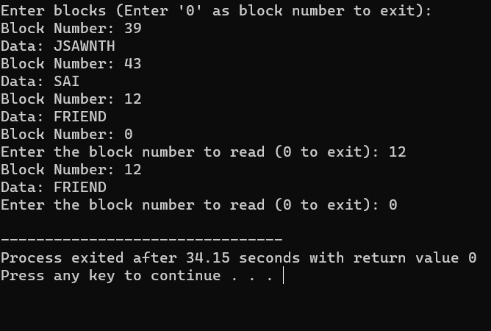

**36. With linked allocation, each file is a linked list of disk blocks; the disk blocks may be scattered anywhere on the disk. The directory contains a pointer to the first and last blocks of the file. Each block contains a pointer to the next block. Design a C program to simulate the file allocation strategy.**

**PROGRAM:**

#include <stdio.h>

#include <stdlib.h>

// Structure to represent a block struct Block { char data[256]; // Adjust the size as needed for your blocks struct Block* next;

};

int main() { struct Block* firstBlock = NULL; // Pointer to the first block in the linked list struct Block* lastBlock = NULL; // Pointer to the last block in the linked list

int blockCount = 0; // Count of blocks in the linked list

int blockNumber; char data[256]; char choice;

printf("Linked Allocation Simulation\n");

while (1) { printf("Enter 'W' to write a block, 'R' to read a block, or 'Q' to quit: "); scanf(" %c", &choice);

if (choice == 'Q' || choice == 'q') { break;

}

if (choice == 'W' || choice == 'w') { printf("Enter data for the block: "); scanf(" %[^\n]", data);

// Create a new block

struct Block* newBlock = (struct Block*)malloc(sizeof(struct Block)); for (int i =

0; i < 256; i++) { newBlock->data[i] = data[i];

}

newBlock->next = NULL;

if (blockCount == 0) {

// This is the first block firstBlock = newBlock; lastBlock = newBlock;

} else {

// Link the new block to the last block lastBlock->next = newBlock; lastBlock = newBlock;

}

blockCount++;

} else if (choice == 'R' || choice == 'r') { printf("Enter the block number to read (1-%d): ", blockCount); scanf("%d", &blockNumber);

if (blockNumber < 1 || blockNumber > blockCount) { printf("Invalid

block number. The valid range is 1-%d.\n",

blockCount);

} else { struct Block* currentBlock = firstBlock; for

(int i = 1; i < blockNumber; i++) { currentBlock = currentBlock->next;

}

printf("Block %d Data: %s\n", blockNumber, currentBlock->data);

}

}

}

// Free the allocated memory for blocks before exiting struct Block* currentBlock = firstBlock; while (currentBlock != NULL) { struct Block* nextBlock = currentBlock->next; free(currentBlock); currentBlock = nextBlock;

}

return 0; }

**OUTPUT:**

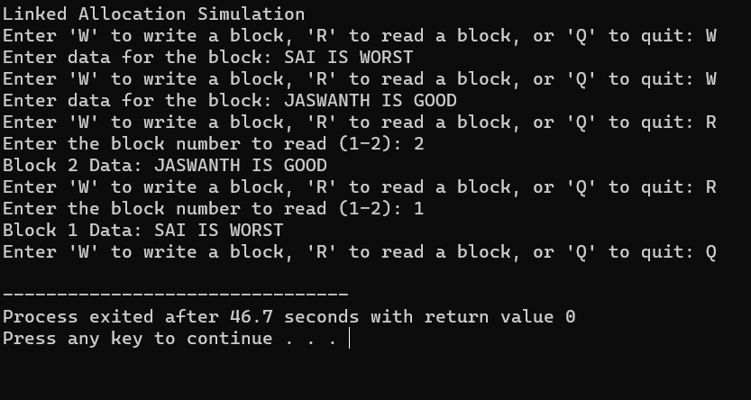

**37.Construct a C program to simulate the First Come First Served disk scheduling algorithm.**

1. Start at the current position of the disk head.
2. For each disk request in the queue:

* Move the disk head to the requested track.
* Calculate the seek time as the absolute difference between the new position of the disk head and the previous position.
* Add the seek time to the total seek time.
* Update the previous position of the disk head to the current position.

1. Repeat step 2 for all disk requests in the queue.
2. After serving all the requests, calculate and display the total seek time.
3. Calculate and display the average seek time, which is the total seek time divided by the number of requests.

**PROGRAM:-**

#include <stdio.h>

#include <stdlib.h>

int main() {

int n, head, seek_time = 0;

printf("Enter the number of disk requests: "); scanf("%d", &n);

int request_queue[n];

printf("Enter the disk request queue:\n"); for (int i = 0; i < n; i++) { scanf("%d", &request_queue[i]);

}

printf("Enter the initial position of the disk head: "); scanf("%d", &head);

// FCFS Scheduling

printf("\nFCFS Disk Scheduling:\n"); printf("Head Movement Sequence: %d", head); for (int i = 0; i < n; i++) { seek_time += abs(head - request_queue[i]); head = request_queue[i]; printf(" -> %d", head);

}

printf("\nTotal Seek Time: %d\n", seek_time); printf("Average Seek Time: %.2f\n", (float) seek_time / n);

return 0;

}

**OUTPUT:-**

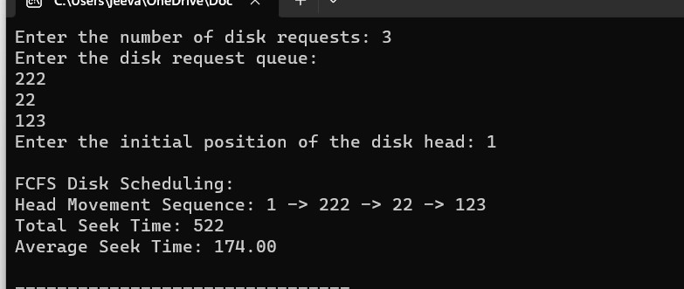

**38. Design a C program to simulate SCAN disk scheduling algorithm**.

**PROGRAM:**

#include <stdio.h>

#include <stdlib.h>

int main() {

int n, head, seek_time = 0;

printf("Enter the number of disk requests: "); scanf("%d", &n);

int request_queue[n];

printf("Enter the disk request queue:\n"); for (int i = 0; i < n; i++) { scanf("%d", &request_queue[i]);

}

printf("Enter the initial position of the disk head: "); scanf("%d", &head);

// Sort the request queue to simplify SCAN algorithm for (int i

= 0; i < n - 1; i++) { for (int j = i + 1; j < n; j++) {

if (request_queue[i] > request_queue[j]) { int temp = request_queue[i]; request_queue[i] = request_queue[j]; request_queue[j] = temp;

}

}

}

// SCAN (Elevator) Scheduling

printf("\nSCAN (Elevator) Disk Scheduling:\n"); int start

= 0; int end = n - 1;

int current_direction = 1; // 1 for moving right, -1 for moving left

while (start <= end) {

if (current_direction == 1) { for (int i = start; i <= end; i++) {

if (request_queue[i] >= head) {

seek_time += abs(head - request_queue[i]); head = request_queue[i]; start = i + 1; break;

} }

current_direction = -1; // Change direction

} else { for (int i = end; i >= start; i--) {

if (request_queue[i] <= head) {

seek_time += abs(head - request_queue[i]); head = request_queue[i]; end = i - 1;

break;

} }

current_direction = 1; // Change direction

}

}

printf("Total Seek Time: %d\n", seek_time); printf("Average Seek Time: %.2f\n", (float)seek_time / n);

return 0;

}

**Output:-**

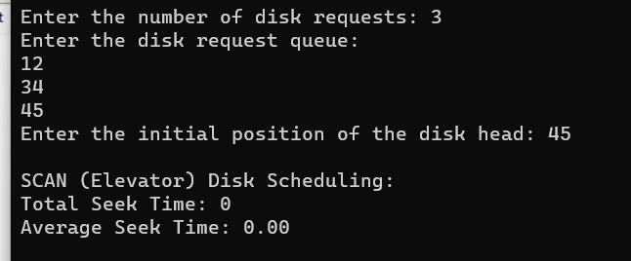

**39. Develop a C program to simulate C-SCAN disk scheduling algorithm**.

**PROGRAM:-**

#include <stdio.h>

#include <stdlib.h>

int main() { int n, head, seek_time = 0;

printf("Enter the number of disk requests: ");

scanf("%d", &n);

int request_queue[n];

printf("Enter the disk request queue:\n"); for (int i = 0; i < n; i++) { scanf("%d", &request_queue[i]);

}

printf("Enter the initial position of the disk head: "); scanf("%d", &head);

// Sort the request queue for simplicity for

(int i = 0; i < n - 1; i++) { for (int j = i + 1; j < n; j++) { if (request_queue[i] > request_queue[j]) { int temp = request_queue[i]; request_queue[i] = request_queue[j]; request_queue[j] = temp;

} }

}

// C-SCAN Scheduling

printf("\nC-SCAN Disk Scheduling:\n"); int start = 0;

int end = n - 1;

while (start <= end) { for (int i = start; i <= end; i++) { if

(request_queue[i] >= head) { seek_time += abs(head - request_queue[i]); head = request_queue[i]; start = i + 1;

}

}

// Move the head to the end in the current direction seek_time += abs(head - 0); head = 0;

// Change direction to the opposite side seek_time += abs(head - request_queue[end]); head = request_queue[end];

end = n - 2; // Exclude the last request, as it has already been served

}

printf("Total Seek Time: %d\n", seek_time); printf("Average Seek Time: %.2f\n", (float)seek_time / n);

return 0;

}

**OUTPUT:-**

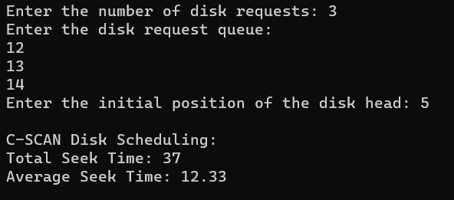

**40. Illustrate the various File Access Permission and different types users in Linux.**

#include <stdio.h>

#include <stdlib.h>

#include <sys/stat.h>

int main() { char filename[] = "file.txt";

int new_permissions = S_IRUSR | S_IWUSR | S_IRGRP | S_IWGRP | S_IROTH; // rw-rwr--

if (chmod(filename, new_permissions) == 0) { printf("File permissions changed successfully.\n");

} else { perror("chmod"); return 1;

}

return 0;

}

**OUTPUT:**

